##### Minor Project-I

SKIN DISEASE DETECTION APP

*Submitted in the partial fulfillment for the award of the degree of*

# BACHELOR OF ENGINEERING

### IN

### B.E. CSE (HONS.) WITH SPECIALIZATION IN ARTIFICIAL INTELLIGENCE AND MACHINE LEARNING IN ASSOCIATON WITH IBM

### Submitted by:

### KARUNA RANI -20BCS6700

### PAMKAJ SINGH KANYAL -20BCS6668

### MANAS MISHRA -20BCS6695

### JATIN SHARMA -20BCS6697

### 

### Under the Supervision of:

### LEEZA SHARMA MA’AM



### CHANDIGARH UNIVERSITY, GHARUAN, MOHALI - 140413,

**PUNJAB**

#### FEBRUARY, 2022

**DECLARATION**

*I, ‘****KARUNA, PANKAJ, MANAS & JATIN****, students of* ***‘Bachelor’s of engineering in CSE (HONS.) with specialization in artificial intelligence and machine learning in association with IBM’ , session: 2020-24****, Department of Computer Science and Engineering, Apex Institute of Technology, Chandigarh University, Punjab, hereby declare that the work presented in this Project Work entitled ‘****SKIN DISEASE DETECTION APP****’ is the outcome of our own bona fide work and is correct to the best of our knowledge and this work has been undertaken taking care of Engineering Ethics. It contains no material previously published or written by another person nor material which has been accepted for the award of any other degree or diploma of the university or other institute of higher learning, except where due acknowledgment has been made in the text.*

**Name – KARUNA RANI(20BCS6700)**

**PANKAJ SINGH KANYAL(20BCS6668)  
MANAS MISHRA(20BCS6695)**

**JATIN SHARMA(20BCS6697)**

**ABSTRACT**

*Dermatology is the branch of bioscience that's involved with diagnosing and treatment of skin based mostly disorders. The immense spectrum of dermatologic disorders varies geographically and additionally seasonally because of temperature, humidness and alternative environmental factors. Human skin is one amongst the foremost unpredictable and tough terrains to mechanically synthesize and analyze because of its quality of unevenness, tone, presence of hair and alternative mitigating options. Though, many researches are conducted to find and model human skin victimization (PC Vision techniques), only a few have targeted the medical paradigm of the matter. Due to lack of medical facilities available in the remote areas, patients usually ignore early symptoms which may worsen the situation as time progresses. Hence, there is a rising need for automatic skin disease detection system with high accuracy. Thus, we develop an application to differentiate between Healthy Skin Vs Skin suffering from a Diseases like eczema , melanoma , acne , chickenpox , blister and psoriases with their symptoms and cures . We have used teachable machines to train our app, Teachable Machine is a web-based tool that makes creating machine learning models fast, easy, and accessible to everyone. Teachable Machine is a web-based tool that makes creating machine learning models fast, easy, and accessible to everyone . In our model we have uploaded multiple images related to a particular disease and it’ll automatically detect the disease according to data available . Teachable machines uses the tensorflow library which will directly help in integrating it to out flatter applications thus in a very short period of time gives the accurate results, thereby promoting and supporting development of Dermatology*

**ACKNOWLEDGMENT**

*It is indeed with a great pleasure and immense sense of gratitude that we acknowledge the help of these individuals. We are highly indebted to our Chancellor S****. SATNAM SINGH SANDHU****, VICE CHANCELLOR* ***Dr. H.B. RAGHAVENDR****, CHANDIGARH UNIVERSITY, for the facilities provided to accomplish this main project .We would like to thank our P.L.* ***SHIKHA GUPTA MA’AM*** *,* *for this constructive criticism throughout our project. We feel elated in manifesting our sense of gratitude to our internal project guide*  ***LEEZA SHRAM MA’AM*** *. She has been a constant source of inspiration for us and we are very deeply thankful to her for her support and valuable advice. We extremely grateful to our Departmental staff members for their extreme help throughout our project. Finally we express our thanks to all of our friends who helped us in successful completion of this project.*

***Project Associates:***

*KARUNA RANI(20BCS6700)*

*PANKAJ SINGH KANYAL (20BCS6668)*

*MANAS MISHRA(20BCS6795)*

*JATIN SHARMA(20BCS6697)*

**Table of Contents**

1. Title page
2. Declaration
3. Abstract
4. Acknowledgement
5. Table of content

* **INTRODUCTION**
* **PROBLEM INTORDUCTION**
* **METHODOLOGY USED**
* **DISEASES DETECTED IN OUR SYSTEM**
* **USER CHARACTE RISTICS**
* **SYSTEM FEATURES**
* **REQUIRENMENT SPECIFICATIONS**

1. *INTRODUCTION*
2. *HARDWARE REQUIRENMENTS*
3. *SOFTWERE REQUIRENMENTS*

* **SYSTEM ATTRIBUTES**
* **SYSTEM DESIGEN**

*PHYSICAL DESIGN*

**

*DATA BASE DESIGN*



* **RESULTS**
* **CONCLUSION**
* **REFERENCES**

**INTRODUCTION**

Skin diseases are more common than other diseases. Skin diseases may be caused by fungal infection, bacteria, allergy or viruses, etc. A skin disease may change texture or color of the skin. In general, skin diseases are chronic, infectious and sometimes may develop into skin cancer. Therefore, skin diseases must be diagnosed early to reduce their development and spread. The diagnosis and treatment of a skin disease takes longer time and causes financial and physical cost to the patient.

In general, most of the common people do not know the type and stage of a skin disease. Some of the skin diseases show symptoms several months later, causing the disease to develop and grow further. This is due to the lack of medical knowledge in the public. Sometimes, a dermatologist (skin specialist doctor) may also find it difficult to diagnose the skin disease and may require expensive laboratory tests to correctly identify the type and stage of the skin disease. The advancement of lasers and photonics based medical technology has made it possible to diagnose the skin diseases much more quickly and accurately. But the cost of such diagnosis is still limited and very expensive. Therefore, we propose an image processing-based approach to diagnose the skin diseases. This method takes the digital image of disease effect skin area then use image analysis to identify the type of disease. Our proposed approach is simple, fast and does not require expensive equipment's other than a camera, a computer and an android/ios device.

**PROBLEM INDUCTION:**

**1.EXPENSIVE TREATMENT :**

The advance laser techniques and photonics based medical technology is still limited and hence expensive.

**2.LACK OF KNOWLEDGE:**

Most of the common people do not know the type, symptoms and stage of a skin disease.

**3.BUSY SCHEDULES:**

People find it difficult to take a break from their busy life’s and take an appointment for a dermatologist. That’s why many people ignore the skin related problems.

**4.SKIN DISEASES ARE COMMON IN INDIA:**

These days, skin related problems are very common in India. Some of the reasons are polluted air, non-nutritious food, garbage, climate changes etc.

**5.SOMETIMES DIFFICULT FOR DERMATOLOGIST TO RECTIFY THE CAUSE:**

Some of the diseases show symptoms several months later. Some type of diseases changes the texture and color of the skin. That’s why it becomes difficult sometimes for the dermatologist to rectify the actual cause on time.

**METHODOLOGY USED**

In developing SKIN DISEASE DETECTION the following steps were taken –

* ***PLANNING***

A project plan was developed as well as other planning documents was also discussed by the team members . Planning provided us the basis for acquiring the resources needed to achieve a solution . This phase of our project helped us in finding out that what was the actual dilemmas that are needed to be solved .

* ***ANALYSIS***

At this point , the manual system in place was analyzed to determine where the problem was , in an attempt to solve the system . This step involved breaking down the system in different pieces to analyze the situation , analyzing project goals , breaking down what needed to be created and an attempt to engage users so that definite requirements could be defined .

To avoid communication gaps between members the following techniques were used in analysis to gather information

* ***SEMI-STRUCTURED INTERVIEWS***

Semi structured interviews were conducted with a fairly open framework which allowed us to have a focused conversational , two way communication . It was used as both to give and receive information . This tool was used as a data collection methodology because it is less intrusive .

* ***DIRECT OBSERVATIONS***

Direct observation was used as a research methodology of choice in designing the management system for hospital because observations give additional , more accurate information on behavior of people than interviews or questionnaires.

* ***USING AVAIABLE INFORMATION***

In the development of hospital management system , this research methodology was mainly used in the analysis and design phases of the system development process . This is because it will permit the researcher to analyze changes in trends.

***Diseases detected in our system-***

* HIVES

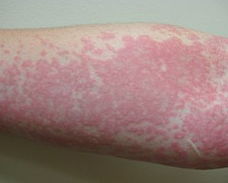

* BLISTER

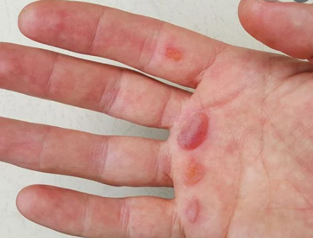

* ACNE

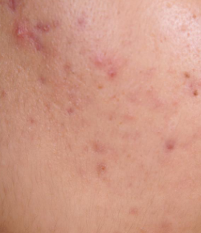

* CHICKENPOX

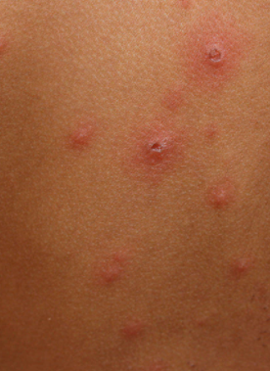

* ECZEMA

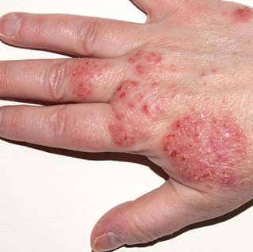

* MELANOMA

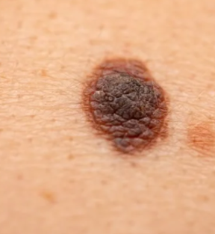

* PSORAISES

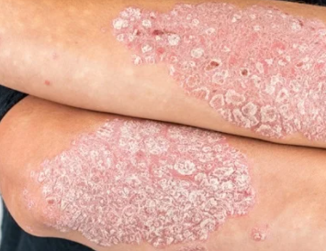

**User characteristics**

1. **Educational Level**: At least a school-student should be comfortable along with knowledge of English language.
2. **Technical Expertise**: Should be a high or middle level employee of the organization comfortable with using general purpose applications on a computer.

**SYSTEM FEATURES**

* *Welcome page module*
* *DO’S AND DON’TS*
* *ABOUT US*
* *UPLOADING IMAGE MODULE*
* *ABOUT DISEASE AND CLASSIFICATION*
* *RESULTS*

**REQUIRENMENT SPECIFICATIONS**

**INTRODUCTION:**

To be used efficiently, all computer software needs certain hardware components or the other

software resources to be present on a computer. These pre-requisites are known as

(computer)system requirements and are often used as a guideline as opposed to an absolute rule.

Most software defines two sets of system requirements: minimum and recommended. With

increasing demand for higher processing power and resources in newer versions of software,

system requirements tend to increase over time. Industry analysts suggest that this trend plays

a bigger part in driving upgrades to existing computer systems than technological advancements

.

**HARDWARE REQUIREMENTS:**

The most common set of requirements defined by any operating system or software application is the physical computer resources, also known as hardware. A hardware requirements list is often accompanied by a hardware compatibility list (HCL), especially in case of operating systems. An HCL lists tested, compatibility and sometimes incompatible hardware devices for a particular operating system or application. The following sub-sections discuss the various aspects of hardware requirements.

***HARDWARE REQUIREMENTS FOR PRESENT PROJECT***

PROCESSOR: dell inspiron , i5RAM: 8 GBHARD DISK: 1 TB

SYSTEM SPECIFICATIONS: 64-bit operating system, x64-based processor

**SOFTWARE REQUIREMENTS:**

Software Requirements deal with defining software resource requirements and pre-requisites that need to be installed on a computer to provide optimal functioning of an application. These requirements or pre-requisites are generally not included in the software installation package and need to be installed separately

**SOFTWARE REQUIREMENTS FOR PRESENT PROJECT:**

OPERATING SYSTEM: Windows 10 Pro

SOFTWARE INSTALLED- VISUAL STUDIO CODE, FLUTTER, ANDROID STUDIO, TENSORFLOW LITE, TEACHABLE MACHINES

**System Attributes**

* *Reliability*

This application is a reliable product that produces fast and verified output of all its processes.

* *Availability*

This application will be available to use and help them to carry out their operations conveniently.

* *Security*

The application will never use the images uploaded by the user other than the rectifying and classification purposes.

* *Maintainability*

The application will be designed in a maintainable manner. It will be easy to incorporate new requirements in the individual modules.

* *Portability*

The application will be easily portable on any windows-based system .

**SYSTEM DESIGN**

The purpose of Design phase is to plan a solution for problem specified by the requirements. System design aims to identify the modules that should be in the system, the specification of those modules and how they interact with each other to produce the results. The goal of the design process is to produce a model that can be used later to build that system. The produced model is called design of the system. System design is the process of defining the architecture, components, modules, interfaces and data for a system to satisfy specified requirements. Normally, the design proceeds in two stages:

* Physical design
* Database design

***PHYSICAL DESIGEN***

***LEVEL 0-***

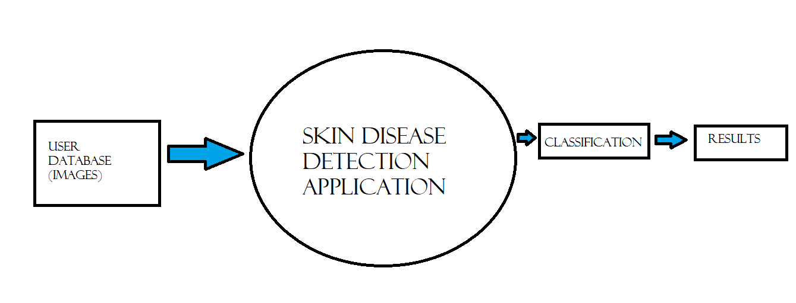

***LEVEL 1-***

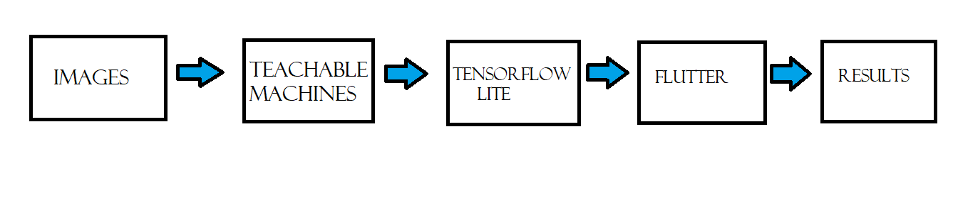

* ***DATA BASE DESIGN (****Welcome page module)*

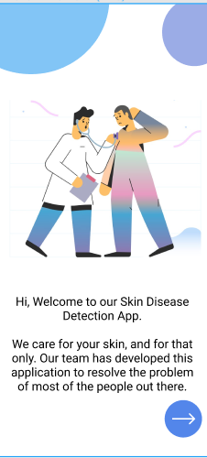

* *DO’S AND DON’TS*

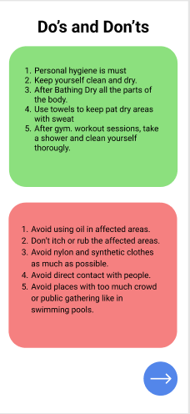

* *ABOUT US*



* *UPLOADING IMAGE MODULE*

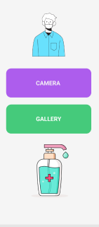

* *RESULTS*

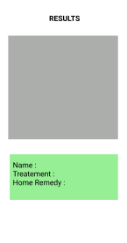

**CONCLUSION**

The proposed system is able to detect the skin disease with promising results combining computer vision and machine learning techniques. It can be used to help people from all over the world and can be used in doing some productive work. The tools used are free to use and are available for the user, hence, the system can be deployed free of cost. The application developed is light-weight and can be used in machines with low system specifications. It has also a simple user interface for the convenience of the user. The image processing and machine learning algorithms were successfully implemented.

**REFERENCES**

* Search engines
* Google
* Wikipedia
* Coding websites
* Pre- knowledge of flutter/dart
* YouTube